THE ANALYSIS OF PATHWAY TO ENGLISH FOR THE PERFORMANCE OF NOUGHTS AND CROSSES GAME IN TEACHING VOCABULARY TO THE TENTH GRADE STUDENTS OF SENIOR HIGH SCHOOL

Satria Adhi Putra Perdhana¹, Junaedi Setiyono², Zulia Chasanah³
{donisatria39@gmail.com¹, junaedi.setiyono@yahoo.co.id², zuliachasanah@yahoo.com³}

English Language Education, Purworejo Muhammadiyah University¹⁾
English Language Education, Purworejo Muhammadiyah University²⁾
English Language Education, Purworejo Muhammadiyah University³⁾

Abstract. One of the main problems of students in learning English subject is the lack of vocabulary. Vocabulary is a language component which closely related to one of the four language skills, i.e. reading. This research aims at finding (1) which parts of Pathway to English appropriate for performing Noughts and Crosses Game are, and (2) how to use Noughts and Crosses Game in teaching vocabulary to the tenth grade students of senior high school. The research is a qualitative research using descriptive analysis proposed by Cohen for analysing the data. The data are taken from the content of Pathway to English. The research findings showed that from 10 chapters in Pathway to English, chapter 3, 4, 6, 7, and 10 are not appropriate for performing Noughts and Crosses game in vocabulary teaching because these chapters contain lessons which do not support to hold Noughts and Crosses Game. It means that these chapters are the lack of texts which are long or complicated enough to perform Nought and Crosses Game. On the other hand, chapter 1, 2, 5, 8, and 9 are appropriate for performing Noughts and Crosses Game in vocabulary teaching due to the availability of texts needed. It can be concluded that only 50% of the chapters can be used to perform Noughts and Crosses game.
Keywords: Pathway to English; Noughts and Crosses Game; Vocabulary Teaching.
1 Introduction
As we know English is an international language. English is not only as means of communication but also as scientific language as a standard. There are many the usage of English which we can find in newspaper, magazine, book, journal, article, and so on. So without mastering English we will be left behind in science and we will struggle in communicating with foreigner and native speaker.
Language consist of four skills and two components such as listening reading, writing, speaking, vocabulary, and grammar. In learning the four skills, the students also have to master the language components. Vocabulary is one of the important foundations if the students want to master English subject.
Based on the researcher’s observation in Magang I, the students are still struggle in mastering language components in English subject such as grammar, vocabulary, phonology, pronunciation, and so on. In this thesis the researcher want to discuss about teaching vocabulary in senior high school.
Based on the researcher’s experience in Magang III for teaching students in the eleventh grade in SMA N 1 Klirong, the students oftenly are not understand the meaning vocabulary in some word and the grammatical structure in the text. Sometimes the students ask about the meaning of some words to the researcher as teacher. So they usually use online dictionary or dictionary in form of book. As the researcher have stated before, the students have to master the four basic skills in learning English such as listening, speaking, reading, and writing. If we pay attention to the 2013 curriculum that discuss about the quality of teaching and learning especially in English subject, student has to be more participate in class activities than the teacher.
Senior high school students face many problem in learning English. One of the problem is mastering vocabulary in English subject. Most of students struggle in understanding the meaning of words. So the main problem of students is lack of vocabulary. In this thesis, the researcher want to find which parts of Pathway to English that can be used to teach vocabulary in solving the lack of vocabulary of the students.
There are two solution that the teacher can use such as method, and media. In method the teacher can use the interesting classroom activities, it will help the students to enjoy in teaching and learning activity. If the teacher use memorize method, students actually will be bored because of traditional method like that. In teaching and learning, the teacher can use media as a tool for teaching. One of the interesting media is game, as we know everyone like to play game. No matter the age of the player, adult people and children are like to play game.
According to [1] Sirbu (2017) when dealing with games, the students were comfortable, relaxed; they gained, self confidence, spontaneity and receptivity. It means that game have many advantages, the students as language learner will feel comfortable and relaxed if the teacher use game as a media in teaching strategy.
The researcher choose game as a media in teaching strategy because the researcher hope that game will help students to understand the material which has been delivered by the teacher easily. The researcher think that game can attract the student’s interest in teaching and learning activity, not only that game also can make the relationship between teacher and student become closer.
The main instrument in teaching and learning of teacher is English course book such as Pathway to English, Look Ahead, and so on. Textbook or course book is important to find the appropriate material in teaching, and also to expand the student’s vocabulary mastery by utilizing the availability of exercises in Pathway to English. Teaching vocabulary to the senior high school students is not easy. Because English is a foreign language for Indonesian students and it is not their mother tongue in their childhood’s environment. They have to learn English in school from junior high school until they are in senior high school based on the 2013 curriculum.
In learning English, there are many components that the student has to master, such as basic skills and language components of English. There are four basic skills in English such as speaking, listening, writing, and reading. Frequently, the student is having struggle in speaking what they will explain about their idea, and also having struggle in listening.
The one way to attract the interest of student in learning English is using game as a strategy of teaching and learning especially in vocabulary teaching. Noughts and Crosses can be a good idea for the strategy of teacher in order to the student will be more participated in teaching and learning activity. This strategy in vocabulary teaching need a process, as have stated by [1] Sirbu (2017) he states that teaching English to young learners is considered to be a process as complex as the learning process. It means that the students are not directly understand the context of material but they need process to understand what the teacher means.
In this thesis, the researcher want to find which parts of Pathway to English that can be used to teach vocabulary in solving the lack of vocabulary of the students. The main instrument in teaching and learning of teacher is English course book such as Pathway to English, Look Ahead, and so on. Textbook or course book is important to find the appropriate material in teaching, and also to expand the student’s vocabulary mastery by utilizing the availability of exercises in Pathway to English.
Teaching vocabulary to the senior high school students is not easy. Because English is a foreign language for Indonesian students and it is not their mother tongue in their childhood’s environment. They have to learn English in school from junior high school until they are in senior high school based on the 2013 curriculum.
In learning English, there are many components that the student has to master, such as basic skills and language components of English. There are four basic skills in English such as speaking, listening, writing, and reading. Oftenly, the student is having struggle in speaking what they will explain about their idea, and also having struggle in listening.
As the researcher have stated before, the students have to master the four basic skills in learning English such as listening, speaking, reading, and writing. If we pay attention to the 2013 curriculum that discuss about the quality of teaching and learning especially in English subject, student has to be more participate in class activities than the teacher. The one way to attract the interest of student in learning English is using game as a strategy of teaching and learning especially in vocabulary teaching. Noughts and Crosses can be a good idea for the strategy of teacher in order to the student will be more participated in teaching and learning activity. This strategy in vocabulary teaching need a process, as have stated by [1] Sirbu (2017) he states that teaching English to young learners is considered to be a process as complex as the learning process. The students are not directly understand the context of material but they need process to understand what the teacher means.
The researcher may conclude that vocabulary is one of the most important components of learning English. In learning vocabulary the students often have some problem such as understanding the meaning of word expressing their own idea, and so on. In this thesis, the researcher will find the solution to solve those problem with using game such as Noughts and Crosses. From the background described above, the researcher is interested in investigating “The Analysis Of Pathway To English For The Performance Of Noughts and Crosses Game In Teaching Vocabulary To The Tenth Grade Students Of Senior High School”.

2 Method
- Research Design
According to [2] Creswell (2009:3), research design is plan and the procedure for research that span the decision from broad assumption to detailed methods of data collection and analysis. This plan involve some decisions that should be used to study a topic. The selection of a research design is also based on the nature of the research problem or issues which will be studied, and the researcher’s personal experiences in accomplishing the teacher apprenticeship program.
In this research, the researcher make a plan and arrange it in certain procedure as a guidance in doing his research. The steps of doing his research are conducting interview to the English teacher; collecting the instruments such as Pathway to English book, journal, and article as data sources; conducting an experiment of Noughts and Crosses Game in home; collecting the data from Pathway to English book; analysing the data.
This research belongs to qualitative research, so the method used are content and descriptive-qualitative methods. These method are chosen because the researcher could not doing the experiment in SMA N 1 Klirong because of COVID-19, so the researcher collect data from Pathway to English book.

- Data Sources
Data can be identified as material of research and can not be identified as subject of research. As material, data are not raw materials but finished materials: they exist because it has been through election and sorting in utterance [3] (Sudaryanto, 1993: 23). The data of this research are content from the Pathway to English book for performing Noughts and Crosses Game toward the students of Senior High School as a teaching instrument.
Data source is a source from obtained data, like human, event, behavior, document, files and other things. According to [4] Aldabbus (2008) the data sources are varied and designed to address the range of research questions. Data source that use in this research is from Pathway to English for performing Noughts and Crosses Game in vocabulary teaching.

- Data Collection
Collecting data is one of the most important part of the research. In collecting the data, the researcher collects the require information from the main sources. According to [5] Creswell (2012:9-10), collecting data means identifying and selecting individuals for a study, obtaining their permission to study them, and gathering information by asking people questions or observing their behaviors.
Based on the theory above the researcher uses Pathway to English as the main instrument that help the researcher to observe and collect the data. Journals and articles as a strenghtened source to the researcher’s content of his reserach. The researcher collects the supporting data from the Google Scholar so that the researcher downloads journals and articles from it. Beside that the researcher asks to the teacher to gather information about vocabulary teaching. There are some techniques of collecting data, as follows:
- Data Making
The researcher conduct and observe the data source by reading all of the journals and thesis carefully as much as possible. Then the researcher organized the data and makes a list of the data based on the steps below, those are :
- Unitizing
The data is found in the book and other sources are relavant to the topic of problem. The analysis of this research is the content in the book which is the answer to the questions stated in the statement of the problem.
- Sampling
The researcher tries to analyze the role of Noughts and Crosses Game toward students’ vocabulary mastery.
- Recording
In recording the data the researcher reads the book. The researcher takes focus on the representative book used as teaching instrument that relates to the topic problem which contains the data to be collected and explained clearly.
- Inference
The design of collecting data is based on analytical construct which is done to the relationship between data and the construct. The data is content of the book where as the data context is the text found from the book.
- Interview
The researcher conduct interview in order to overcome the limitation of collecting the data. The researcher use interview by asking the teacher about teaching vocabulary to the tenth grade students from the teacher’s point of view.

- Data Analysis
The researcher uses a descriptive qualitative design, according to Cohen et al. Qualitative data analysis relates to the organizing, counting, and explaining the data which would like to be analysed. In the research to analyze the problem which is being discussed. All data are analyzed qualitatively and presented descriptively. In processing the data, the researcher uses this analysis. There are some technique of analyzing data, as follows:
- Data Analysis
The researcher presents the data by analysing the content which is related to the topic problem. The data are infromation that are relevant to the observed phenomena.
- Validity
To get validity, the researcher organizes directly the data research which the researcher thinks relevant. And finally, he concludes the findings and displays them in writing.
- Data Reduction
The technique use by the researcher in selecting the data in observing the book, to get the focus on problem, the researcher determines the text and vocabulary knowledge which is will be quiz in the content of the book which is formed of vocabularies. The researcher clears out the irrelevant data from the relevant one.
- Display Data
After data reduction, the data will be presented in data display. In presenting the data, the researcher make summary, schematic, table, and so on. The data which will be presented need to be arranged based on specific criteria.

3 Findings and Discussions
a. Pathway to English as a Senior High School Course Book
The researcher found that Pathway to English book consisted of 10 chapter, and every chapter had different theme of each other. In every chapter there were many practice which will improve the students’ skill such as listening, reading, speaking, and writing, [6] Rohmatillah and Pratama (2017) stated that the learning materials are successfully included and developed supported materials and it interpreted social functions, text structures and language features items completely. This book provided exhaustive material which appropriate with students’ standard competency by 2013 curriculum. As has been stated by [7] Amrina (2018) Pathway to English textbook is good to be used for first grader of senior high schools that have started using 2013 Curriculum. It means that Pathway to English was appropriate to teach English subject especially to teach vocabulary to the students of senior high school.
Theme of chapter 1 is “Hi, My Name Is”, this chapter described how the way people in introducing their personal information. So the main goal of this chapter is the students’ could introduce themselves to others. Chapter 1 focus in giving and response personal information in daily conversation with providing many dialogue practice.
Theme of chapter 2 is “Well Done!”, this chapter described how to say compliments to another people. Students could practice well in giving compliment to others is the goal in this chapter. The focus in this chapter is discussing about compliment such as understanding and practicing compliment.
Theme of chapter 3 is “Congratulations!”, this chapter described how to expressing congratulations. Students were hoped to be able expressing, responding and understanding about congratulations.
Theme of chapter 4 is “I Will Improve My English”, this chapter described about plans or intentions in daily life. Students were hoped could master the social function, structure texts, language features and the usage of expressing plans or intentions.
Theme of chapter 5 is “It’s a Wonderful Place”, this chapter contained material which talking about descriptive text. Students were hoped to be able to make and understand descriptive text of place.
Theme of chapter 6 is “Listen to the school Announcement”, this chapter described how to make, write, and speak an announcement. Beside that the students were hoped to master the parts of announcement such as social function, structure, and language features.
Theme of chapter 7 is “I’ve Been There”, this chapter focused in studying tenses such as simple past and present perfect tenses. In this chapter students were hoped to master simple past and present perfect tenses. Many practice for the students in supporting the material in order to students not only mastered the material but also the practice.
Theme of chapter 8 is “Past Echoes of the Nations”, this chapter described about historical recount text. Students were hoped to be able in practicing historical recount text, such as telling, writing, doing role play, etc.
Theme of chapter 9 is “A Long Time Ago”, this chapter described about narrative text. Narrative text which would be discuss is about legends. The students were hoped can master the social function, structure, and language features.
Theme of chapter 10 is “Sing Your Heart Out!”, this chapter described about song. This chapter focused in studying how to present a song, finding the moral lesson and messages of a song, and also writing lyric.

Table 1. Content of Pathway to English
NO | CHAPTER | NUMBER OF PAGES | PAGES FOR APPLYING NOUGHTS AND CROSSES GAME
1 | HI, MY NAME IS | 26 page(2-28) | Page 24
2 | WELL DONE | 20 page(28-48) | Page 41
3 | CONGRATULATIONS | 12 page(48-60) | -
4 | I WILL IMPROVE MY ENGLISH | 18 page(60-78) | -
5 | IT’S A WONDERFUL PLACE | 32 page(78-110) | Page 84, 105, and 107
6 | LISTEN TO THE SCHOOL ANNOUNCEMENT | 10 page(110-120) | -
7 | I’VE BEEN THERE | 20 page(120-140) | -
8 | PAST ECHOES OF THE NATIONS | 22 page(140-162) | Page 146, 147, 149, 151, and 152
9 | A LONG TIME AGO | 30 page(162-192) | Page 172, and 174
10 | SING YOUR HEART OUT | 9 page(192-201) | -

Based on the table above, there were some chapters that did not appropriate to apply Noughts and Crosses Game in vocabulary teaching. That was chapter 3, 4, 6, 7, and 10. On the other hand chapters 1, 2, 5, 8, and 9 were suitable to apply Noughts and Crosses in vocabulary teaching. On page 24, there was a letter, teacher could delete some words in letter then students could fill the blank spaces with suitable word. On page 41, there was a text, teacher could use that text for blank space quiz. On page 84, there was a text, teacher could use as blank space quiz. On page 105 and 107, there was a descriptive text, teacher could use that as blank space quiz. On page 146 till page 152, there were texts, pictures, blank spaces, tables, columns, bubbles, teacher could utilize all of that to make many quiz. On page 172 and 174, there was a text, teacher could utilize those text into blank space or teacher could give order to the students to read the text carefully.
The researcher found that course book was the main instrument to collect the material for teaching and learning activity. The exercises which available in course book could be a good tool to measure how far the students could master the material that have been delivered. If the students could pass the exercises, it means that the students had mastered the material which had been given by the teacher previously. On the other hand if the students could not pass the exercises, it means that they had not mastered the material. As we know 2013 curriculum required the students to be more active in teaching and learning activity, as has been stated by [8] Prasojo (2014) teaching and learning method also comprehensively change into student-centered. It means that 2013 Curriculum emphasizes the student’s participation in teaching and learning activity. That thing could be applied by instructing the students to perform the exercises in course book. The availability of an exercises in course book had an important function to measure the student’s mastery about the material that has been explained by the teacher.
Pathway to English was a course book which use The 2013 Curriculum as a standard for teaching and learning activity, as has been stated by [9] Sudarwati and Grace (2016) Pathway to English aims to provide a framework for teaching and learning English based on Kurikulum 2013 yang Disempurnakan. Every chapter in this book provided teaching and learning material that contained basic competence which consist of behavior, knowledge, and skill. So in every chapter of this book represented of four basic skills such as listening, reading, writing, and speaking. This book could help the students a lot in understanding the material because of the vocabulary selection which was easier to understand. Beside that the curriculum emphasized the students to be more active in teaching and learning activity.
The researcher used Pathway to English book as a teaching media in conducting the research. One of special features in this book was QR Codes which could help the teacher to access audio recording by using application named Erlangga Reader that could be downloaded from Play Store. By using the special features the teacher could utilize it to test or measure the vocabulary mastery of the students. Not only that the teacher also could expand the listening skill of the students.
The researcher found that Pathway to English are good to be used for teaching vocabulary to the tenth grade senior high school students. From the data which in the table above, there were many pages that the teacher could use for teaching vocabulary such as on page 24, 41, 84, 105, 107, 146, 147, 149, 151, 152, 172, and 174.

b. Noughts and Crosses Games in Language Teaching

Based on the experiment which has been done by the researcher, the researcher found that language game could attract the student’s interest in language teaching. The participation of the students in language teaching could be improved by utilizing language games such as Noughts and Crosses game. Because the students could feel fun or happy when they are playing game, as has been stated by [10] Hadfield (2003) defines game as an activity with rules, a goal and element of fun. The students really enjoyed the language teaching by using game as strategy. From that, the researcher could conclude that language game could be an effective way to attract the student’s interest in language teaching.
Figures 1. Ilustration of Noughts and Crosses Game

Noughts and Crosses game was a strategy game which consist of three groups. Noughts and Crosses consisted of one table which had nine or more box frames, as has been stated by [11] Setyawan (2019) Noughts and Crosses Game is a board game that can be played using the board or paper by drawing nine box frames. Each groups had to fill those column and row with their symbols such as X or O in on the square. If the group could fill the blank text correctly they could fill the column and row one time and so on. So the group which could answer at most will have potential to be the winner, but the other group could block pass the mark, so the first group cannot win easily. Noughts and Crosses was very suitable for performing filling the blank text in quiz. It could entertain the students with challenge of game. So the researcher could take conclusion that Noughts and Crosses game could improve the student’s vocabulary mastery with holding the quiz of filling the blank text.
The researched found that there were many ways that the teacher could use for performing Noughts and Crosses game in learning and teaching activity as follows: the researcher used blank texts and monologue speech to explore the students’ vocabulary mastery. Listening skill was more emphasized on this test. The researcher took two monologue text as a research instrument. From two monologue text the researcher took 19 question, 10 question for first round and 9 question for second round. Then the researcher accessed the QR Codes to get the audio recording. The researcher instruct the students to fill the blank sentences, and if the students can fill the answer correctly they can fill the square with X or O. And after the game end, the researcher evaluated the most of student’s mistakes in filling the blank sentences. After evaluating the student’s mistakes, the researcher explained which parts of speech which the students does not master it. Then the researcher evaluated the confusion of students in filling the blank texts. From those application the researcher can take conclusion that game is an effective way to teach vocabulary, as has been stated by [12] Wang & Briody (2011) the application of games in teaching young children English is indeed a useful way to facilitate student’s English proficiency.

c. Teaching Vocabulary in Senior High School

The researcher found that psychology factor of the students could affect to their performance in learning and teaching activity. There were some factors that affect the student’s performance such as intelligence, motivation, interest, attitude, and talent, as has been stated by [13] Saeed and Neyadi (2010) motivation is one of the essential factors in language learning. Intelligence of students could be a determinant that some students with a good intelligence could understand and master the material easily instead of the students who had a less intelligence. Motivation, and interest were the big factor that affect to the ability of students in understanding the material which had been given by the teacher. Attitude, and talent were the supporting factors that usually the achiever students had a good attitude and talent. So the researcher could take conclusion that there were many factors which affect to teaching and learning activity.
Teaching English to the tenth grade students as language learners was not easy. The researcher found that there were some students that did not pay attention when the lesson was holding. Their interest in vocabulary teaching were low. The students were less interested in teaching and learning vocabulary, they were more interested with their own topic. So the researcher could take conclusion that the students were will be less interested if the strategy of teaching and learning were still using traditional strategy, the students need something special that can motivate them in completing the exercises or just in playing the game. As has been stated by [13] Saeed & Neyadi (2010) in order to enhance learners’ learning of vocabulary, the students need to be motivated to play a game or to complete a task. The teacher could find a good idea that the students needed an entertaining activity such as Noughts and Crosses game.

d. Pathway to English for the Performance of Noughts and Crosses Game in Teaching Vocabulary
Figures 2. Examples of Coursebook Pages
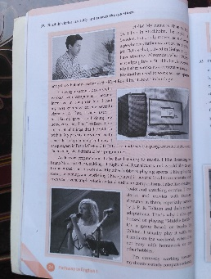 | 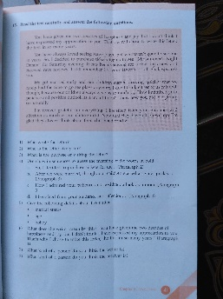 | 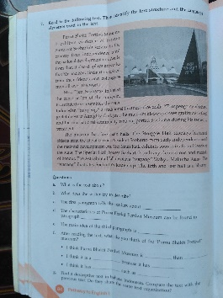
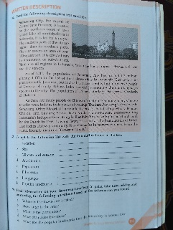 | 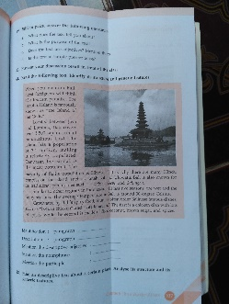 | 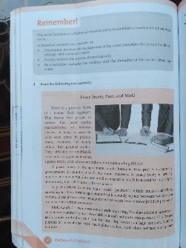
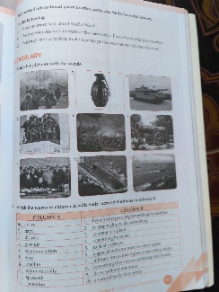 | 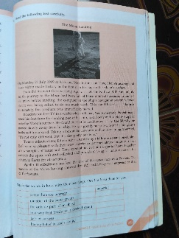 | 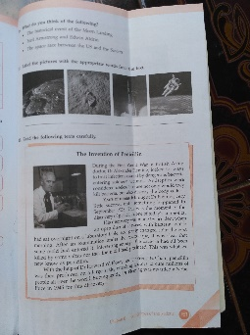
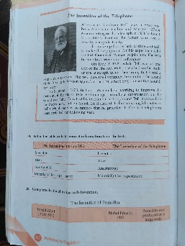 | 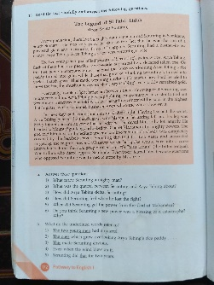 | 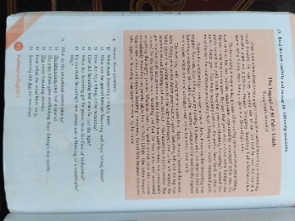

The researcher analyzed all of exercises in the book of Pathway to English in which to determine which part of exercises in the book that appropriate with the kind of game. After analyzing, the researcher chose 2 blank text on page 91 till 93 as quiz of game. This part was on chapter 5 about “It’s a Wonderful Place”. The blank texts were telling about Singapore and London, the reason why researcher chose those blank texts was the topic that familiar to students, so the students does not confuse about the topic of quiz. The blank texts are equipped with barcode, so the researcher could access the audio recording as instrument to conduct the research. There were some pages that could be used to teach vocabulary in Pathway to English book such as on pages 24, 41, 84, 105, 107, 146, 147, 149, 151, 152, 172, and 174.
On page 147, there was a special part that discuss about vocabulary and that was the only one page where the part of vocabulary was written in explicit way. If we paid attention deeply the vocabulary which would be taught is matching, that is:
- Matching the pictures with words
There were 9 pictures in which the students had to match the pictures with suitable words. There was no word which available beside the pictures. So the students had to determine which words that suitable to the pictures.
- Matching the word in column A with column B
There were 2 column which contain column A and column B. Column A contained 10 words and column B contain 10 sentences which will be matched by students.
- Complete the blank spaces with word
There were 10 sentences in which the students had to fill the blank spaces from each sentences.
- Filling the table
The students had to fill the table with topic of moon landing which available on the next page. The students were asked to give their opinion about moon landing
- Reading text
There was a text in which the students have to read it carefully. The theme of text was moon landing.
- Matching the conjunction
There are 2 column which contained of three sentences of each column. The task was the students had to match the conjunctions in bold text with their purposes. Theme of text was about moon landing
- Filling the bubbles
Students were asked to write four feelings or thoughts from Neil Amstrong when he stepped on the .moon based on the text about moon landing.
- Referring numbers
The students were asked to refer the numbers on the column based on the moon landing text.
- Referring pronouns
There were 6 texts where the students are asked to refer the pronouns based on the moon landing text.
- Asking opinion
There were 3 sentences where the students have to give their opinion about it.
- Labelling pictures
There were 4 pictures where the students are asked to label it with the appropriate words from the moon landing text.
- Reading text
There were two texts about “The Invention of Penicillin and The Invention of Telephone” where the students had to read the texts carefully.
- Filling the table
There were 2 column where the students were asked to fill the table with correct information from 2 text.
- Completing timeline
The students had to complete the timeline based on the 2 texts.
- Finding idea
The students were asked to find the main idea of each paragraph from the texts.

In conducting the research, Noughts and Crosses Game gave some benefits for the researcher such as making the lesson becomes more fun, making the relationship between the researcher and students become closer, making students feel more challenging in answering the quiz, and so on. If the students wanted to be the winner of the game, one of them have to answer the game as soon as possible. So the winner get highest score beside of the other students.
In conducting the research, the researcher observed that sometimes the students have difficult to understand the meaning of some words in quiz. So the researcher gave some clue in order to students could understand easier the meaning of word. If one student could not answer the quiz, the researcher would give chance to other students. Beside of giving clue, the researcher also asked the students to spell the word.

e. The Use of Pathway to English for the Performance of Noughts and Crosses Game in Teaching Vocabulary

The researcher found one class which consisted of 35 students in Magang III which lasted two months in SMA N 1 Klirong. The event was holding on July to September 2018. There were 7 boys and 28 girls which would be 3 groups. Then the researcher took three of them as three groups as sample. The research was hold on 26 October 2020.
  - Stage of performing Noughts and Crosses Game in teaching vocabulary:
- First, the researcher divides the students in class into 3 groups which have different symbol such as red team, black team, blue team, etc.
- Second, the researcher explains the game which will be played.
- Third, the researcher starts the game with drawing puzzle box and writing the blank spaces from Pathway to English book.
- Fourth, the researcher plays the audio recording, then asking to groups to fill the blank spaces.
- Fifth, the researcher calculates all of scores of each group.
- Sixth, the researcher determines who is winner of the game.
- Seventh, the researcher analyzes the most wrong answers of students
- Eighth, the researcher explains about student’s mistake, then give evaluation in order the students know the true answer and expand student’s vocabulary mastery.
2. Some ideas to minimize the disadvantages can be done with some ways:
  - Related to words written orthographically
Teacher could make assignment for the students to write five vocabulary everyday on small board per students. Then when the English subject began, teacher could ask the students who write the five vocabulary to memorize and mention those vocabularies.
  - Related to words spoken accepted culturally
Teacher could use the speaker as a learning media beside books in every class which will be hold. With adapting for use speaker in teaching and learning process, the students would felt habitually toward the English speaker. So they could learn listening easily without struggling in understanding the meaning of spoken words. The teacher also could use the appropriate material in the book for teaching listening.
  - Unnatural or unrealistic class environment
Teacher could give some advices for students that playing game is not only had advantages but also has disadvantages. Noughts and Crosses Game was addictive toward students, so the teacher could advise students in order to they do not only focus on the game which unrealistic but they also have to focus on real life situation that is in teaching and learning process.
  - Time-consuming learning-teaching activities
Teacher could divide the time for teaching and learning process and for holding the game. In one meeting could be used to conduct the teaching and learning process fully, and in the next meeting teacher can holding the game but after the game had done the teacher could continue with teaching and learning process. So teaching and learning process was the main focus, beside that time for conduct the teaching and learning process would not be disturbed/ divided with game.

4 Conclusion

Pathway to English were appropriate to perform Noughts and Crosses game. There were some parts in this book which could be applied for performing Noughts and Crosses Game. There were some pages that could be used to teach vocabulary in Pathway to English book such as on pages 24, 41, 84, 105, 107, 146, 147, 149, 151, 152, 172, and 174. On page 147, there was a special part that discuss about vocabulary and that was the only one page where the part of vocabulary was written in explicit way.
There were some stages to perform Noughts and Crosses Game in teaching vocabulary as below:
- First, the researcher divides the students in class into 3 groups which have different symbol such as red team, black team, blue team, etc.
- Second, the researcher explains the game which will be played.
- Third, the researcher starts the game with drawing puzzle box and writing the blank spaces from Pathway to English book.
- Fourth, the researcher plays the audio recording, then asking to groups to fill the blank spaces.
- Fifth, the researcher calculates all of scores of each group.
- Sixth, the researcher determines who is winner of the game.
- Seventh, the researcher analyzes the most wrong answers of students
- Eighth, the researcher explains about student’s mistake, then give evaluation in order the students know the true answer and expand student’s vocabulary mastery.

Acknowledgement

In this opportunity, the researcher wants to thank to the head of SMAN 1 Klirong, and English Teacher. Then, we also wants to thank to the head of English Language Education of Purworejo Muhammadiyah University for allowing us doing this research so that we can write this article completely.

References

[1] A. S. A*, “THE BENEFITS OF GAMES IN TEACHING VOCABULARY TO,” vol. 21, no. 2, pp. 137–148, 2017.

[2] Creswell, John W. (2009). Research Design: Qualitative, Quantitative, and Mixed Methods Approaches. Newbury Park: Sage Publications.

[3] Sudaryanto. 1993. Metode dan Aneka Teknik Analisis Bahasa. Yogyakarta: Duta Wacana University Press.

[4] Aldabbus, S. (2008). An Investigation into the Impact of Language Games on Classroom Interaction and Pupil Learning in Libyan EFL Primary Classrooms. June.
[5] Creswell, J. W. (2012). Education Research. Boston: Pearson Education.
[6] Rohmatillah, R., & Pratama, D. A. (2017). An Analysis of Textbook Entitled “Pathway to English” Published By Erlangga at the First Semester of the 11th Grade of Senior High School. English Education: Jurnal Tadris Bahasa Inggris, 10(2), 326-343.
[7] Amrina.(2018). An Analysis of “Bahasa Inggris” Textbook used in The Second grade of Senior High School.Skripsi. UIN Banda Aceh
[8] Arif Prasojo, The Analysis of the English Textbook “Pathway to English” Used in the First Grade of Senior High School Based on Curriculum 2013.( Department of English Education Faculty of Tarbiya and Teachers’ Training “Syarif Hidayatullah” State Islamic University Jakarta).
[9] TH. M. Sudarwati, E. G. (2016). Pathway To English. Jakarta: Erlangga.

[10] Hadfield, J., & Hadfield, C. (2003). Oxford Basics: Simple Speaking Activities. Oxford University Press.

[11] Setyawan, A. (2019). Final project the effectiveness of noughts and crosses game in improving student’s skill in writing descriptive text.
[12] Wang, Y., & Briody, P. (2011). Investigating the Impact of Using Games in Teaching Children English. 1(1), 127–141. https://doi.org/10.5296/ijld.v1i1.1118
[13] Saeed, O., & Neyadi, A. (n.d.). The Effects of Using Games to Reinforce.

